**1.Write a c program to evaluate code for single linked list**

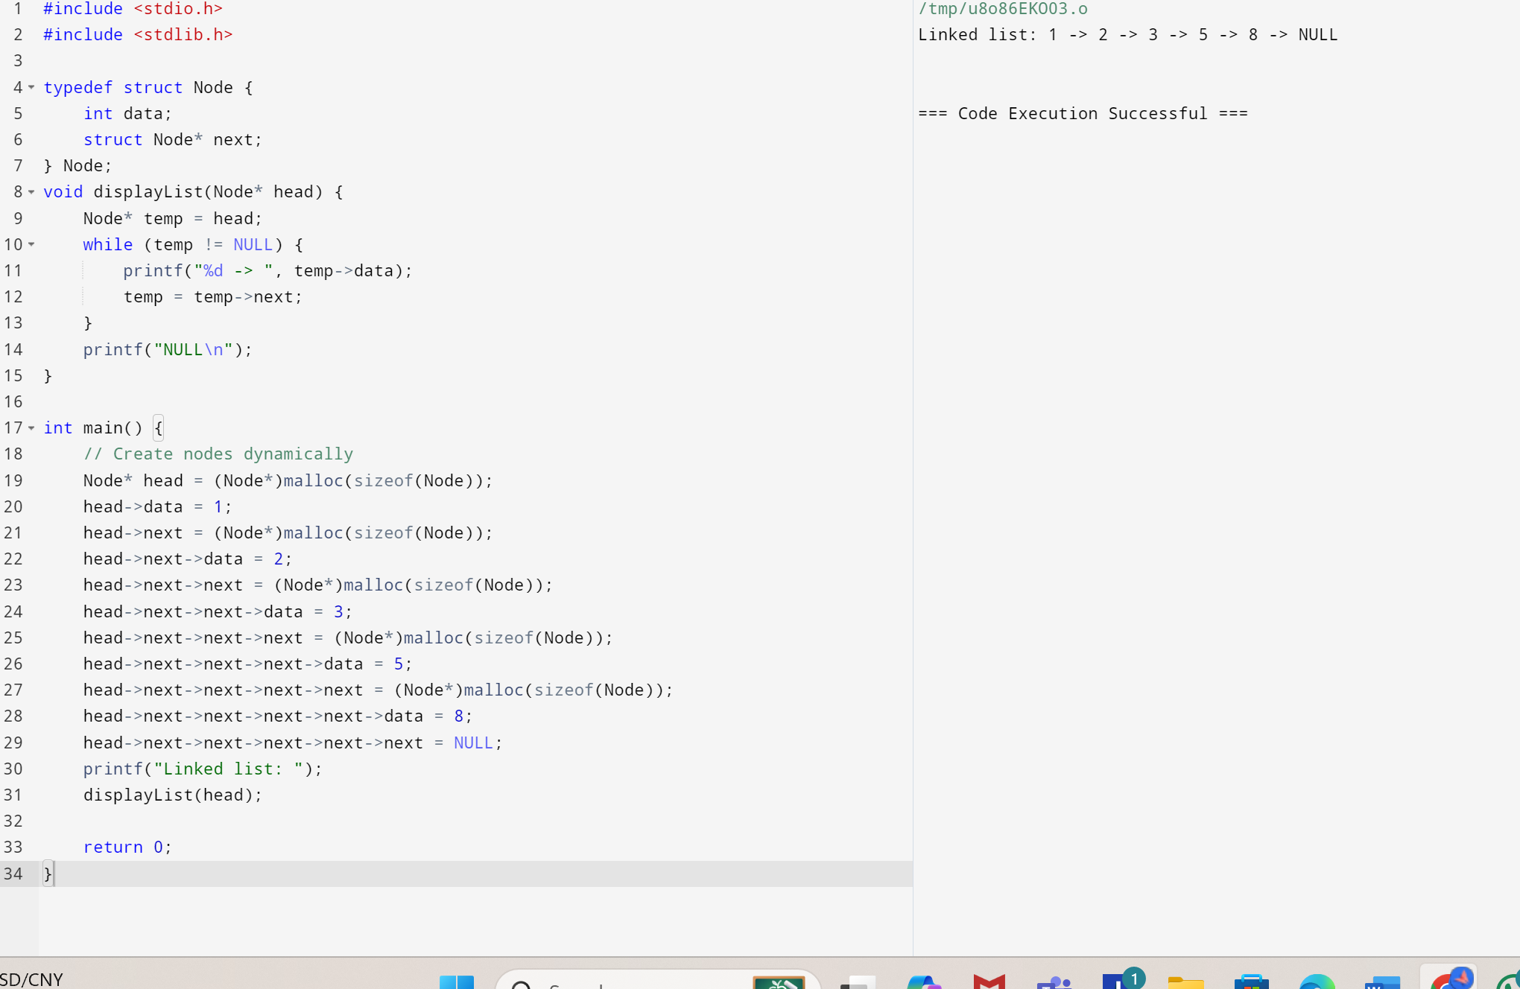

**2.Write a c program to evaluate code for double linked list**

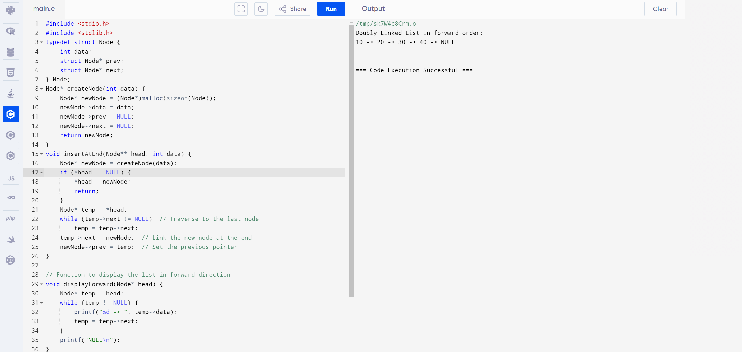

**3.Write a c program to evaluate code for circular linked list**

